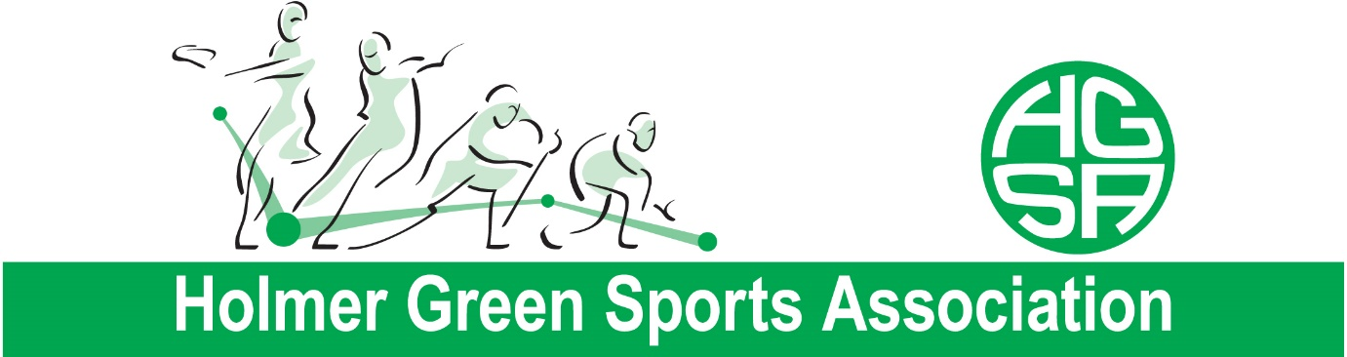

AGM REPORTS 2020
OVERVIEW:
After a fairly stable period from October 2019 to February 2020 for the club, the world went into lockdown and apart from a couple of weeks in the summer when we were permitted to open, HGSA has unfortunately remained closed from 20th March until present (Jan 2021).
Since our last AGM we have seen some staffing changes, our Bar Manager Matt Gomme left HGSA and for a short period Sarah Lawson joined us as his replacement. After the initial lockdown Sarah resigned and Georgia Allen kindly stepped up to help cover the role whilst we were in and out of lockdown situations. A huge thank you to Georgia for all the support.
Speaking of support, we have been truly humbled by the support we received from volunteers throughout the periods of lockdown. Many staff, committee members and HGSA members volunteered to help paint, clean, and tidy the club and its surroundings as well as helping to provide everything necessary to put COVID-19 safety measures in place which allowed us to open briefly in the Summer.
Whilst writing this, we now find ourselves in the third period of lockdown and without much end in sight as to when we will be able to return to all the great events and activities the club and its sections have to offer. We thank everyone for their ongoing support and know that with such a fantastic community, when we can reopen you will all return to HGSA and we very much look forward to being able to welcome you back.
FINANCIAL SUMMARY:
It is very hard to do a comparison on the year before. We have just under a 10k net deficit. We were fortunate to receive 2 government grants, £25000 for the first lockdown and £1000 in December, and at the time of writing the club manager has applied for a number of new grants that have become available since this latest lockdown.
When needed all staff were put on the furlough scheme, only ending when we opened up for the summer, since the December closure staff are back on furlough with Laura and Sam on flexi furlough.
In order to open in the summer, we had to purchase a new glasswasher, this was at a cost of £1500.
Overview of how the finances were managed:
- All outstanding section fees were paid in one lump sum.
- We were given a 1 year holiday from paying our Bucks County Council rates, and LMPC gave us the 6 months we were in lockdown off which equated to £1000, we still have £1002 to pay them before March.
- Adjusted our DD to our energy suppliers when needed.
- Cancelled our bin collection.
- Reduced the amount of cleaning.
- Sky and BT sport were suspended when we were not open.
- 1 year holiday from paying our April 2020 vat, this needs to be paid by March 2021
- Reduced the money being paid to Dayla to manage the finances monthly, we still owe just over £1k to Dayla
- Took a payment holiday with Hampshire Trust (till system) and BNP (Kubota)

